**SC531 – Lecture #07**

**RANDOM VARIABLES**

**Definition:** A **random variable** (RV) X is a function that assigns a *number* *x(s)* to every outcome *s* in the sample space S corresponding to a random experiment E.

Note: This implies that non-numerical outcomes such as *head*, *tail*, *win*, *lose*, *draw* *et cetera* are mapped into numerical values. In experiments with discrete numerical outcomes, we take *x(s)* = *s*.

**Discrete random variables**

These have finite or countably infinite values *x1* , *x2* , ... of the variable X.

Let Prob(X=xi) = pi, for i = 1, 2, ...

Then the values pi, for i = 1, 2, ... define the **probability function** or **probability mass function** of the random variable X, satisfying:

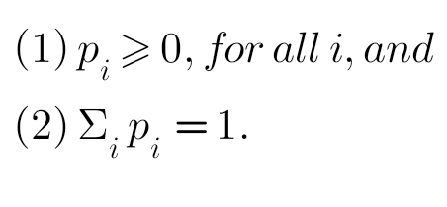

**Continuous random variables**

Random variable X can take any value in an interval, say *a* < *x* < *b*. The probabilities associated with a continuous random variable X are defined by making use of **probability density function** *p(x)*:

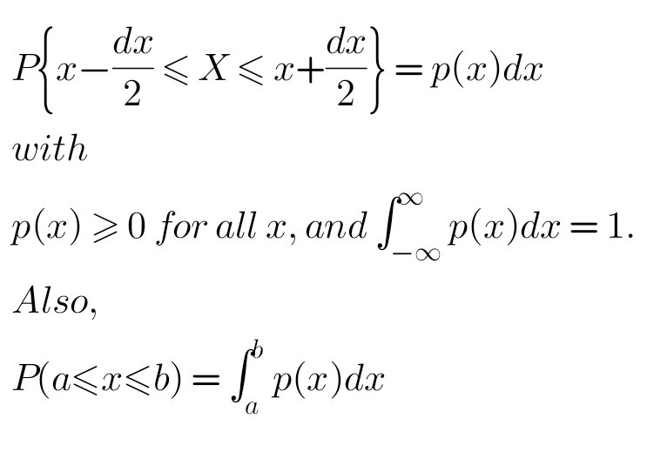

**Cumulative distribution function**

Defined as follows, for discrete and continuous RVs respectively:

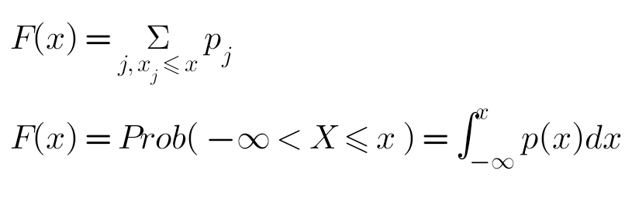

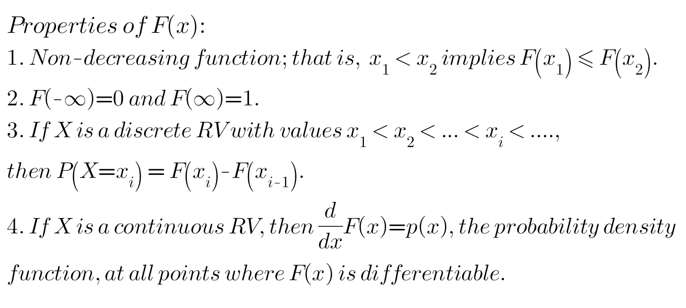



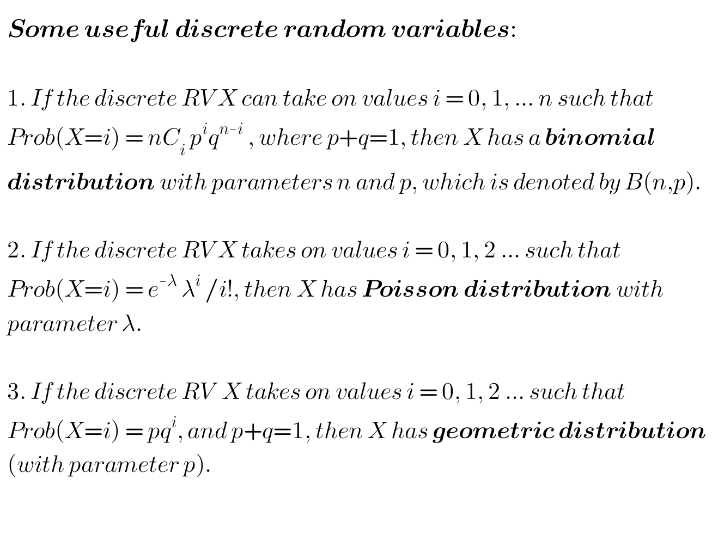

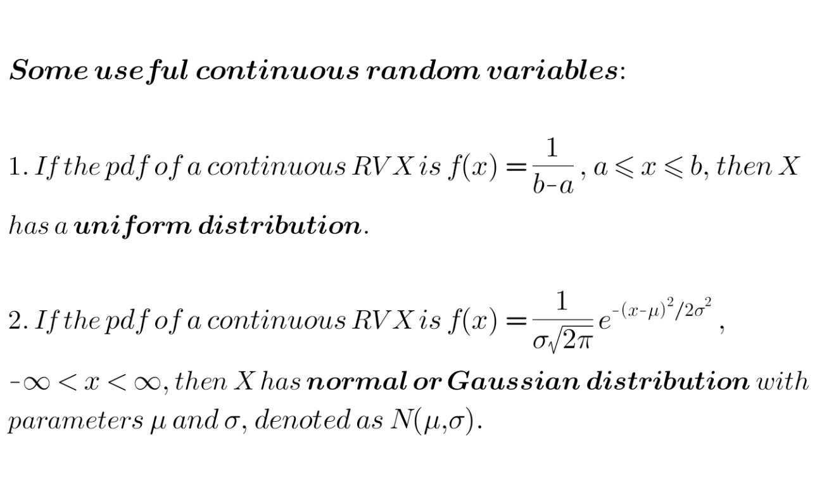We will study random variables (discrete and continuous), and their properties, through a good number of examples. Important theorems will be studied, but usually we will avoid rigorous proofs.

**Rolling a pair of dice:**

The associated RV, which we have already considered, can take on integer values from 2 to 12.

For the probability function and the cumulative distribution, see chart 1 in the Excel file.

**Examples from Ref. #2:**

(1) A lot contains 25 items, of which 5 are defective. From the lot, 4 items are chosen at random without replacement. Let the RV X represent the number of defectives found out the 4 chosen. Find the probability distribution of X.

Possible values of X are: r = 0, 1, 2, 3 or 4.

Prob(X=r) =

Prob(choosing r defectives) * Prob(choosing 4-r good items)

= 5Cr * 20C4-r / 25C4

(2) A lot contains 25 items, of which 5 are defective. From the lot, 4 items are chosen at random with replacement. Let the RV X represent the number of detectives found out the 4 chosen. Find the probability distribution of X.

In this case, we have Bernoulli's trials, with probability of success p = 5/25 = 0.2. Possible values of X are again: r = 0, 1, 2, 3 or 4.

Prob(X=r) = 4Cr pr (1-p)4-r binomial distribution

For these two probability functions, see chart 2 in the Excel file.